MODULE-6(CORE JAVA)
- W.A.J.P to Take three numbers from the user and print the greatest number.
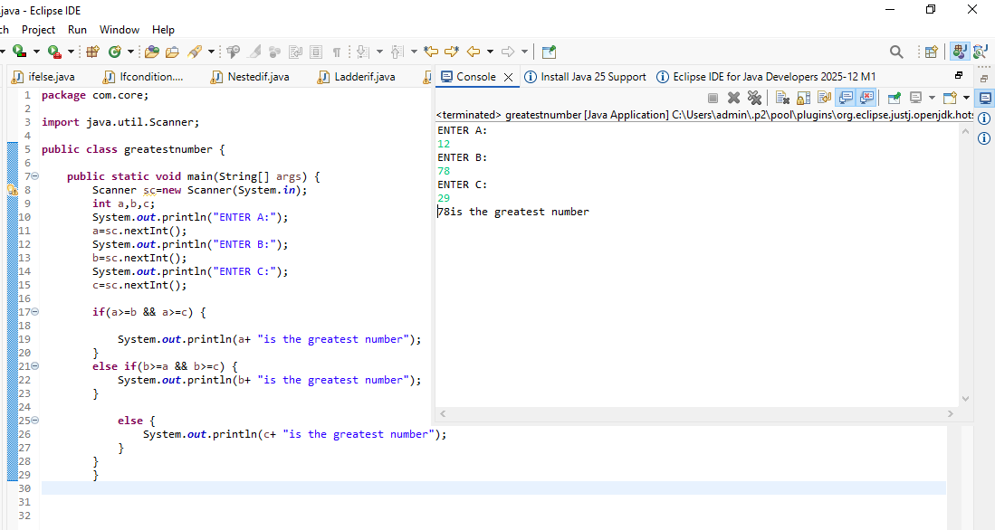

- W.A.J.P in Java to display the first 10 natural numbers using while loop.
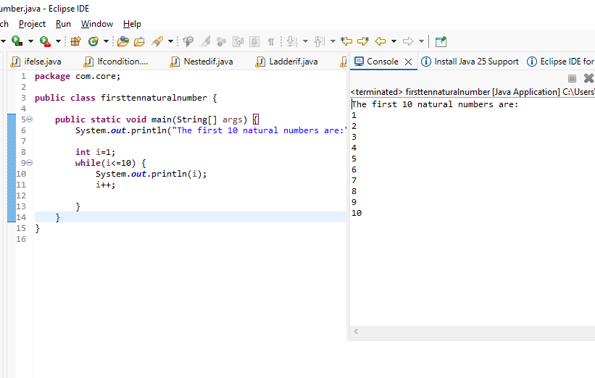

- W.A.J.P to find factorial for Given Number.
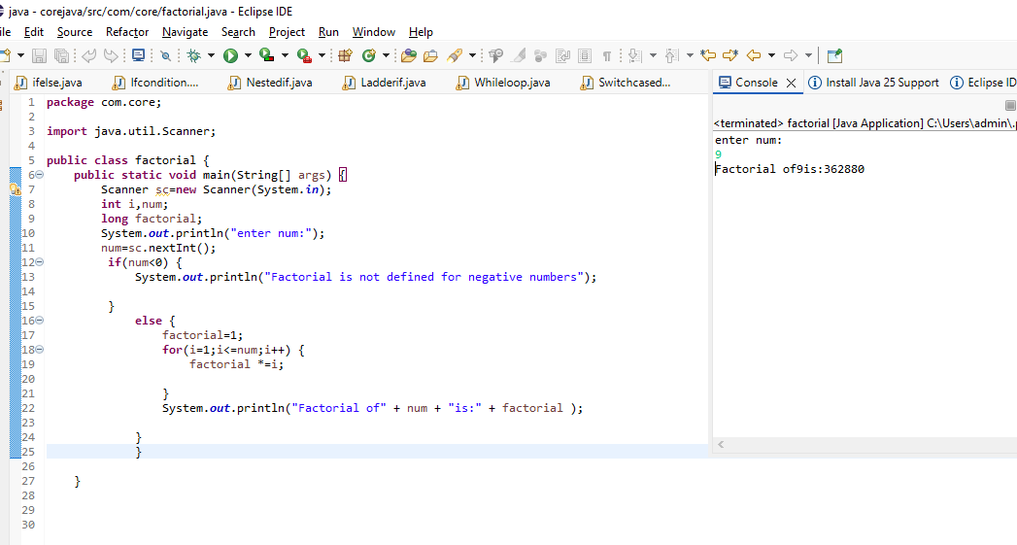

- W.A.J.P to check given number is Prime or not?
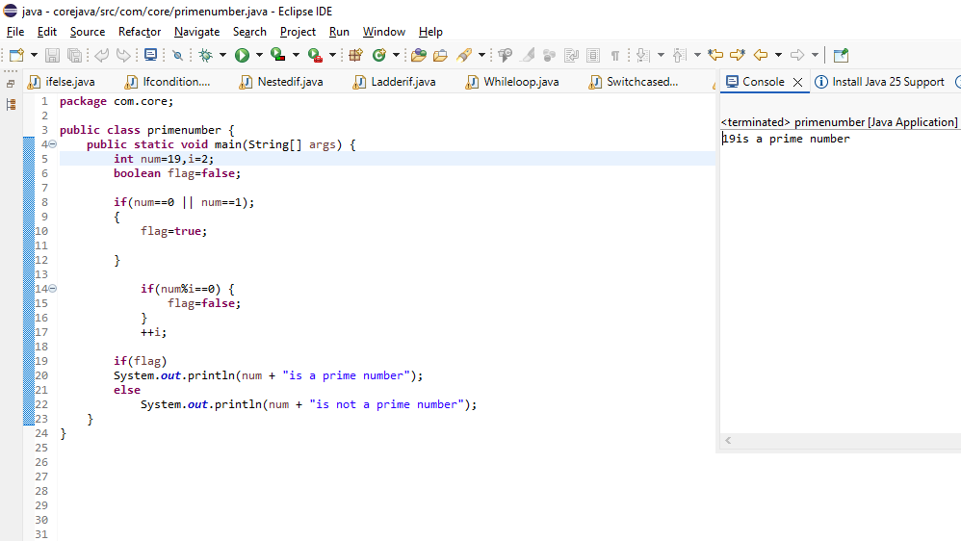

- W.A.J.P to check given number is Armstrong or not?
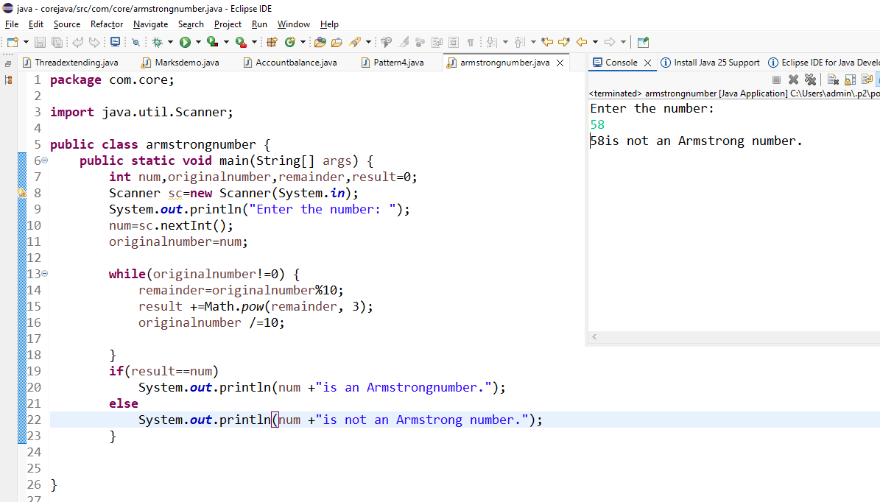

- W.A.J.P for create Fibonacci Series.
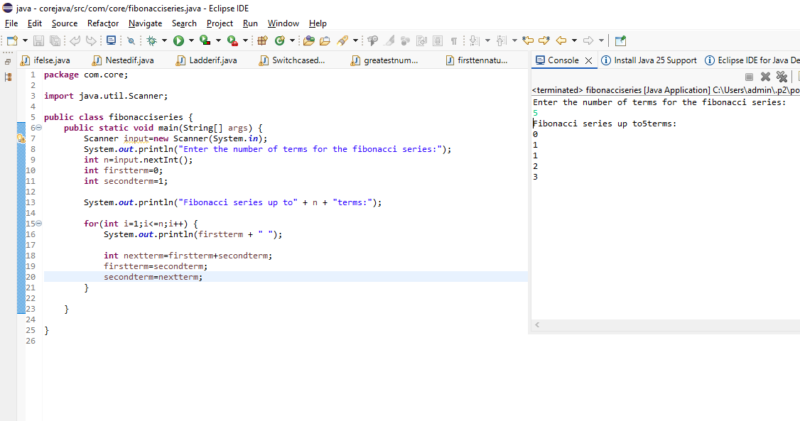
- W.A.J.P to Print pattern Given Below.
1
12
123
1234
12345
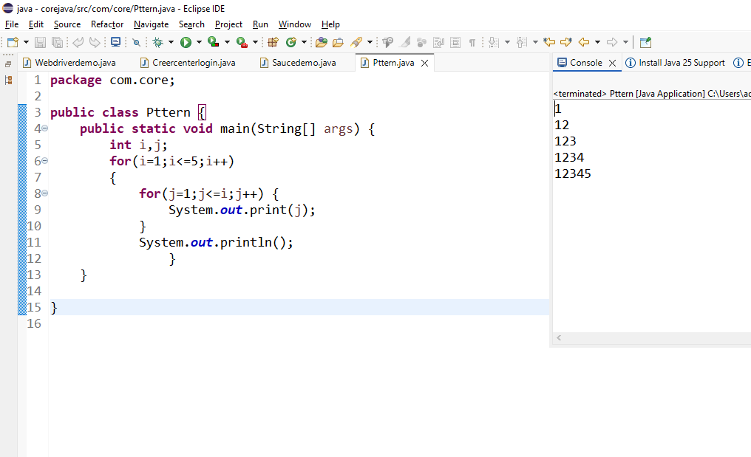

- 1
01
101
01010
101010
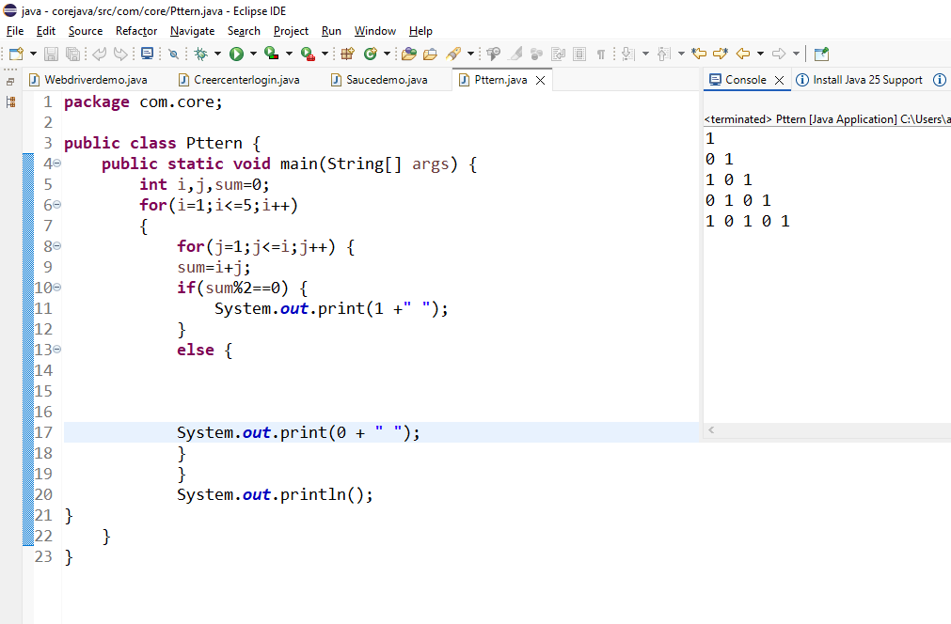
- 1
2 2
3 3 3
4 4 4 4
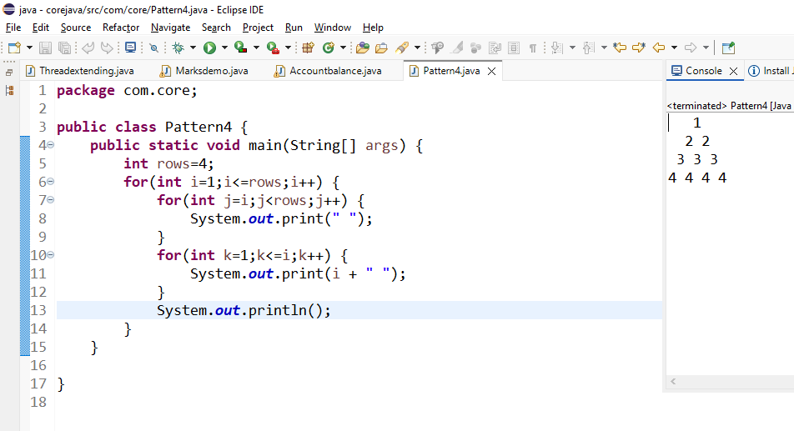
10. *
* * *
* * * * *
* * *
*
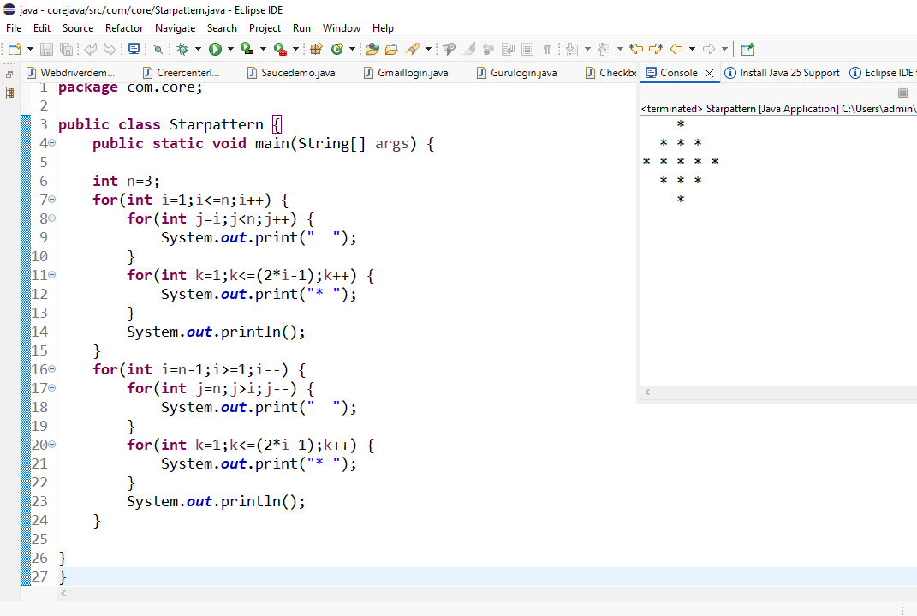
- WAP to compute the sum of the first 100 prime numbers.
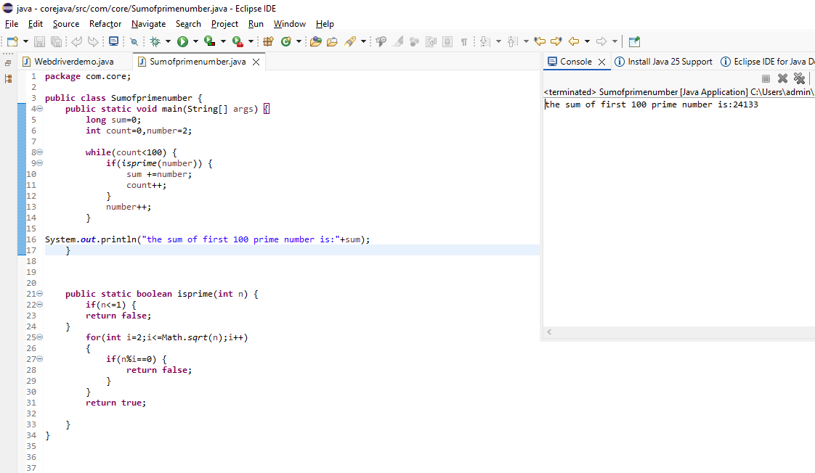
- WAP to sum values of an array.
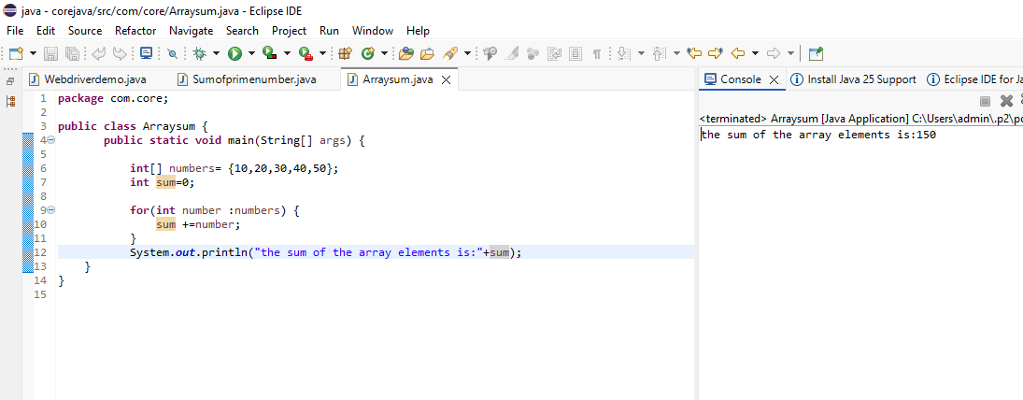
- WAP to calculate the average value of array elements.
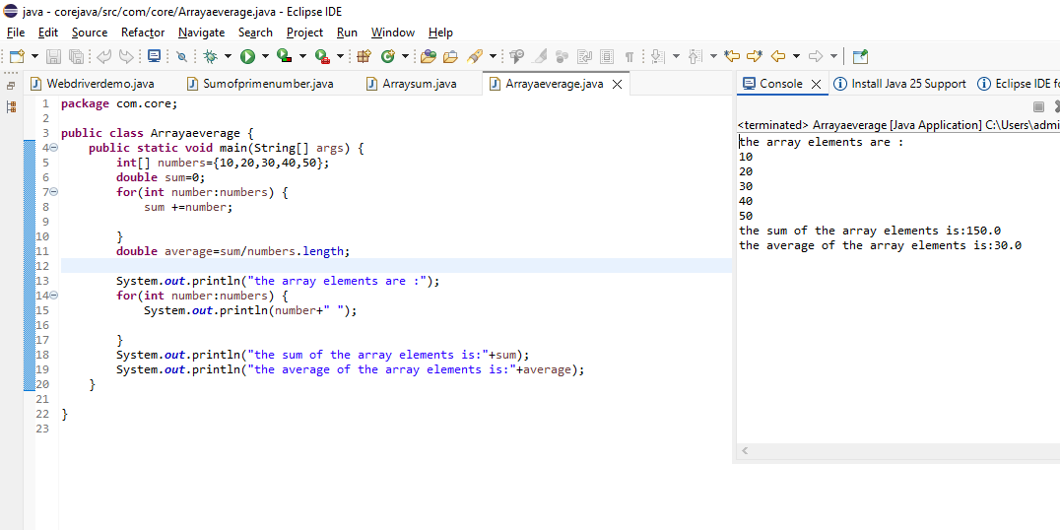
- WAP to find the index of an array element.
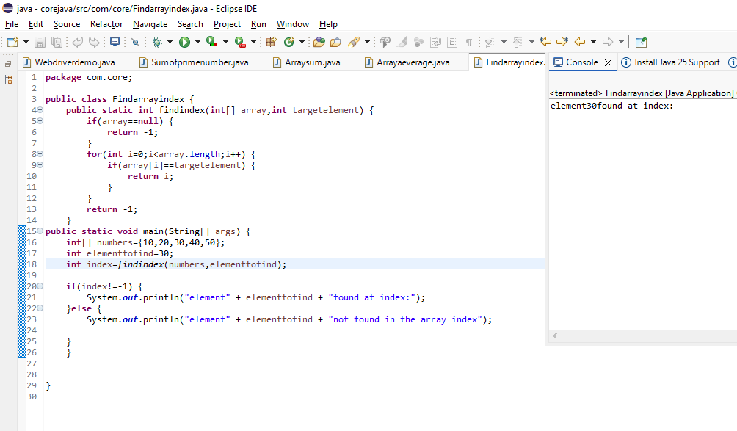
- WAP to find the maximum and minimum value of an array.
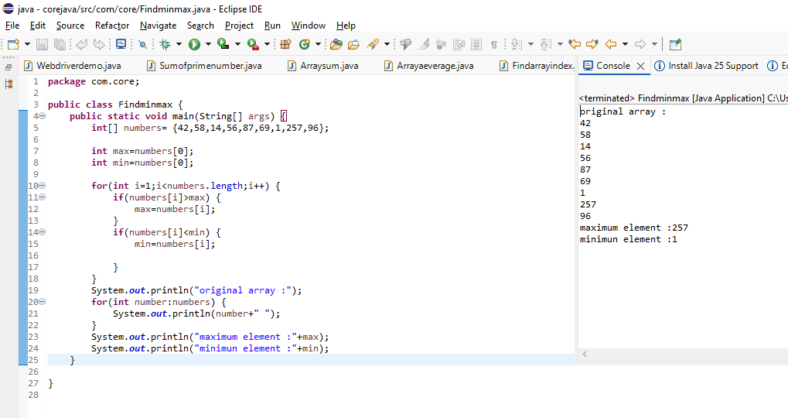
- WAP to Compare Two String.
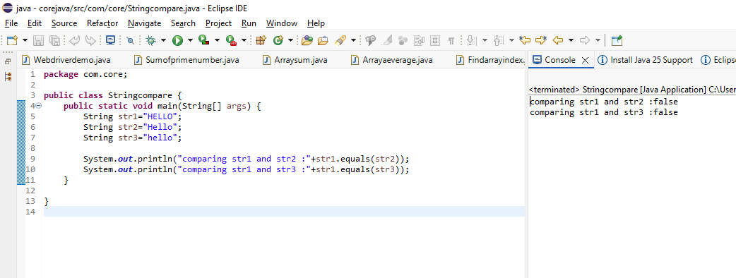

- WAP to concatenate a given string to the end of another string.
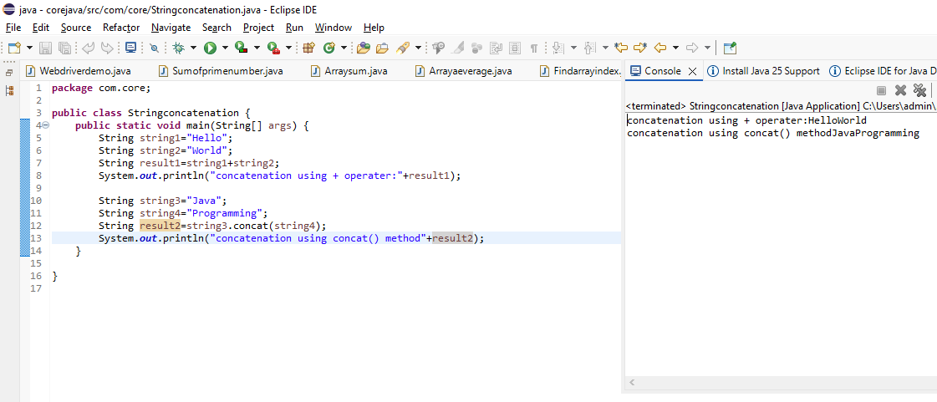

- WAP to demonstrate try catch block.
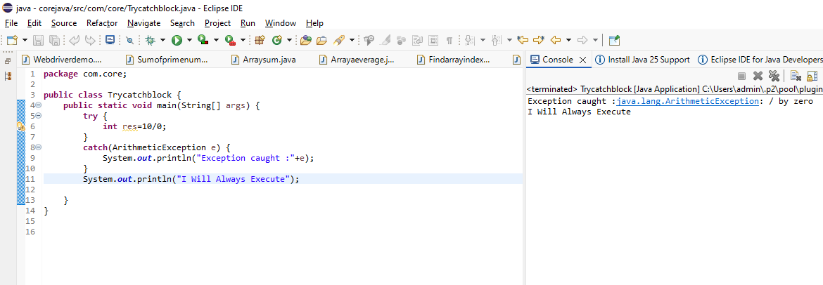
- WAP to demonstrate multiple catch blocks.
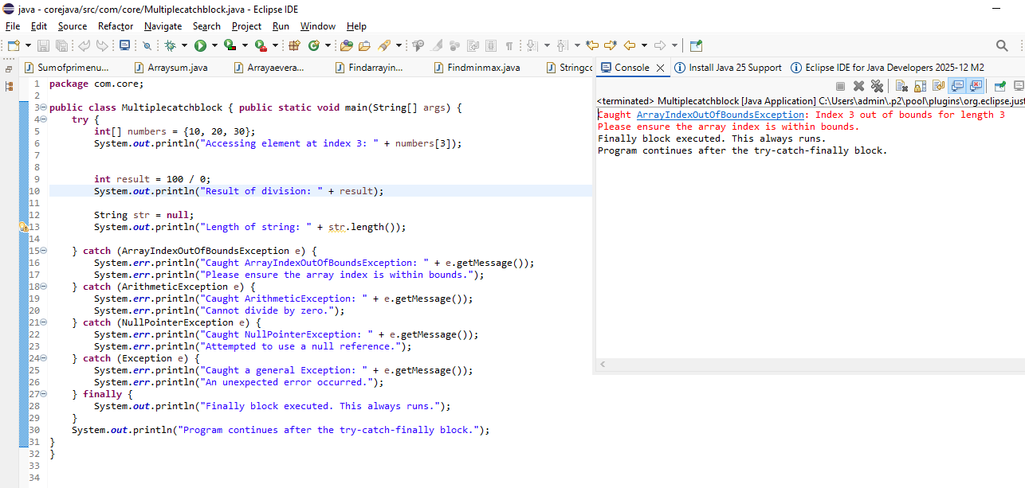
- WAP to create one thread by implementing Runnable interface in Class.
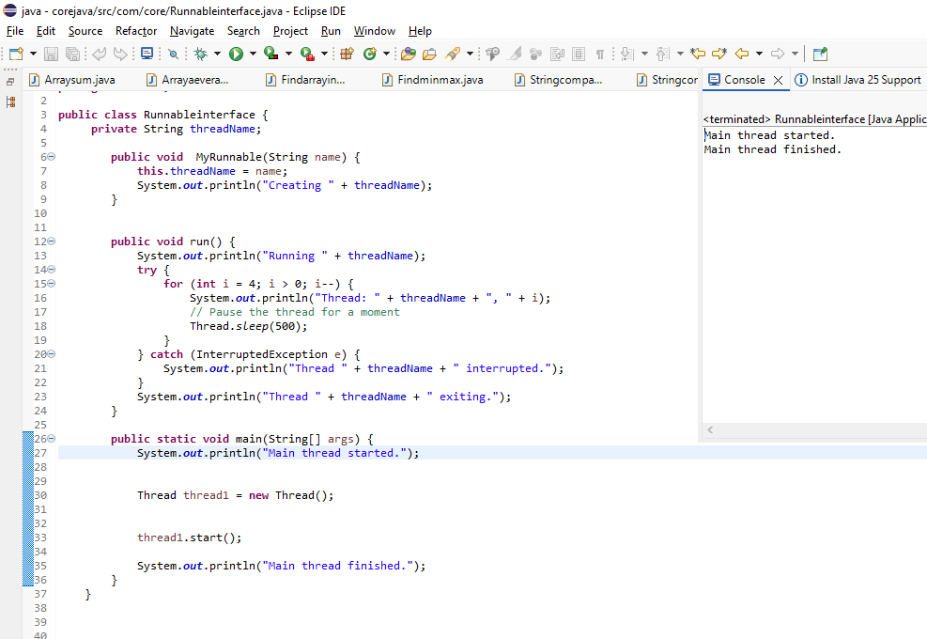
- WAP to create one thread by extending Thread class in another Class.
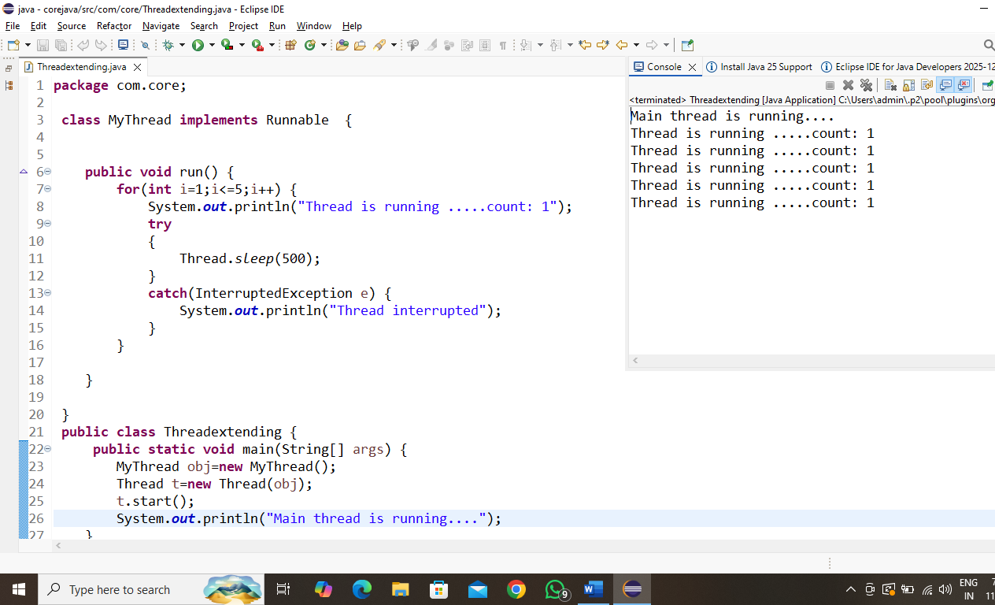

- WAP to iterate through all elements in an array list.
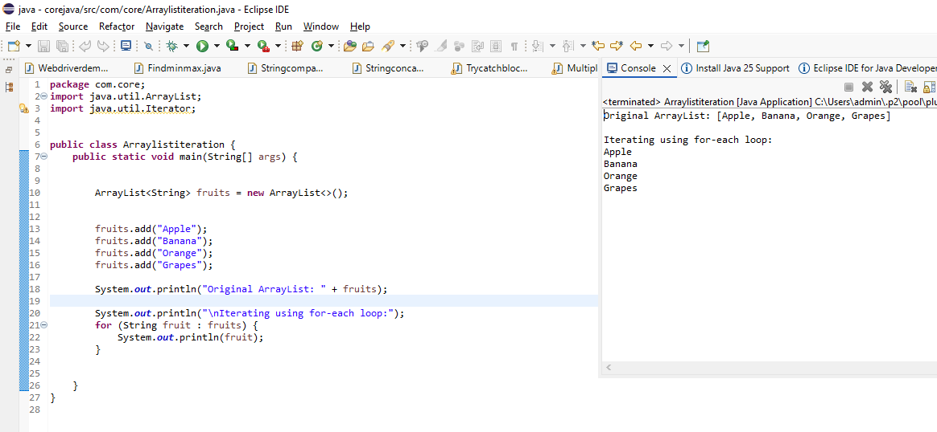

- WAP to update specific array element by given element.
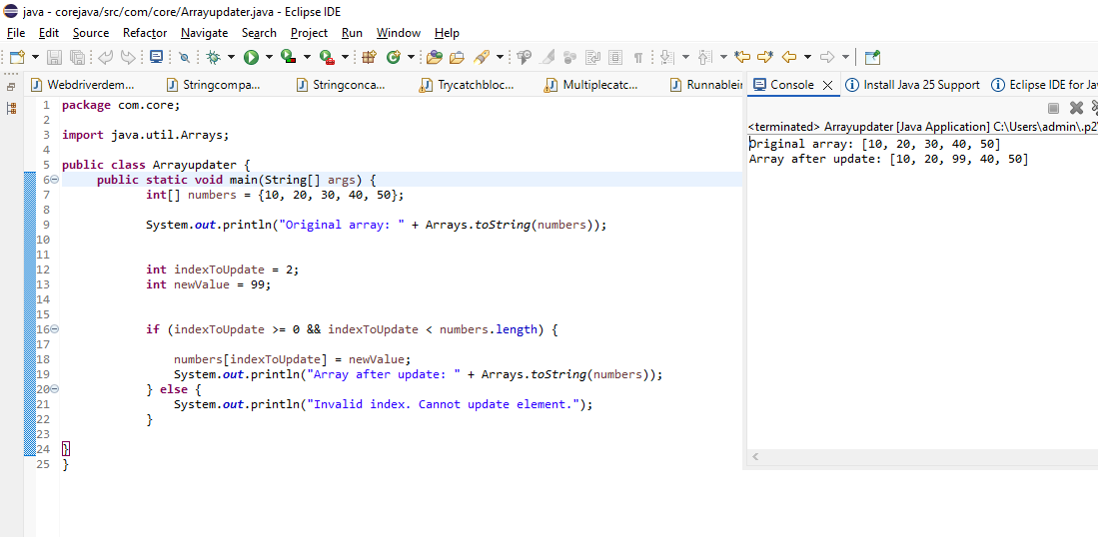
- WAP to remove the third element from a array list.
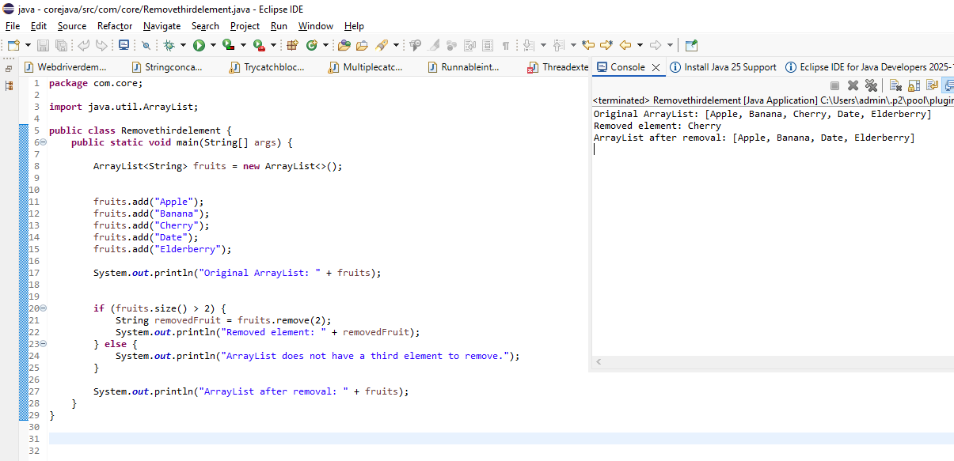

24.WAP to Copy one array into another
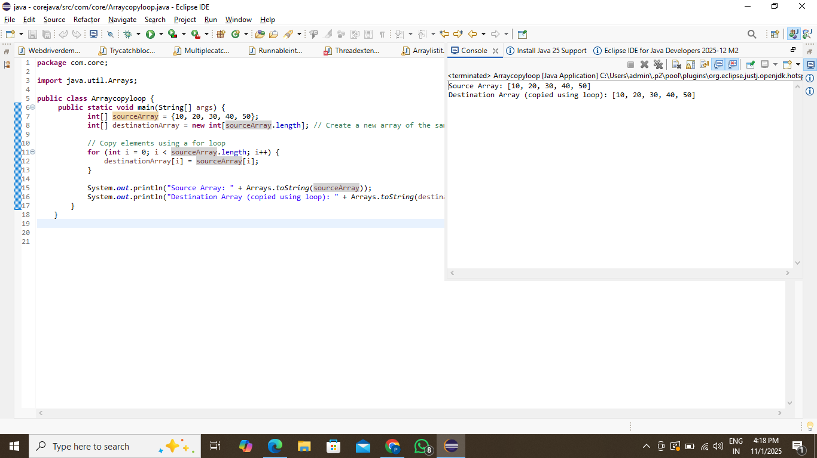
- WAP to reverse an array of integer values.
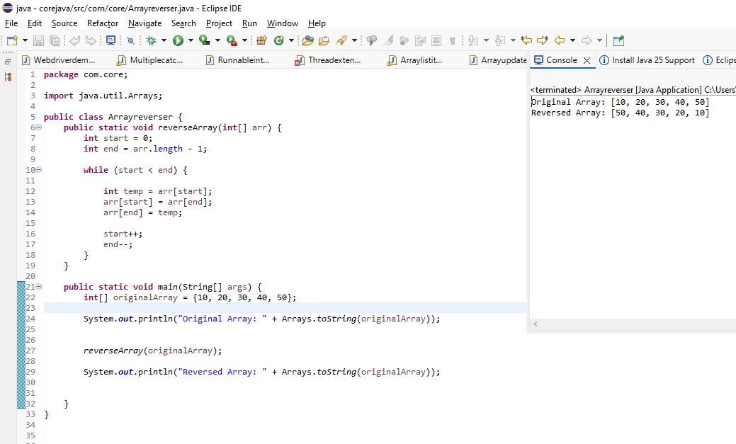

25.WAP to find the second largest element in an array.
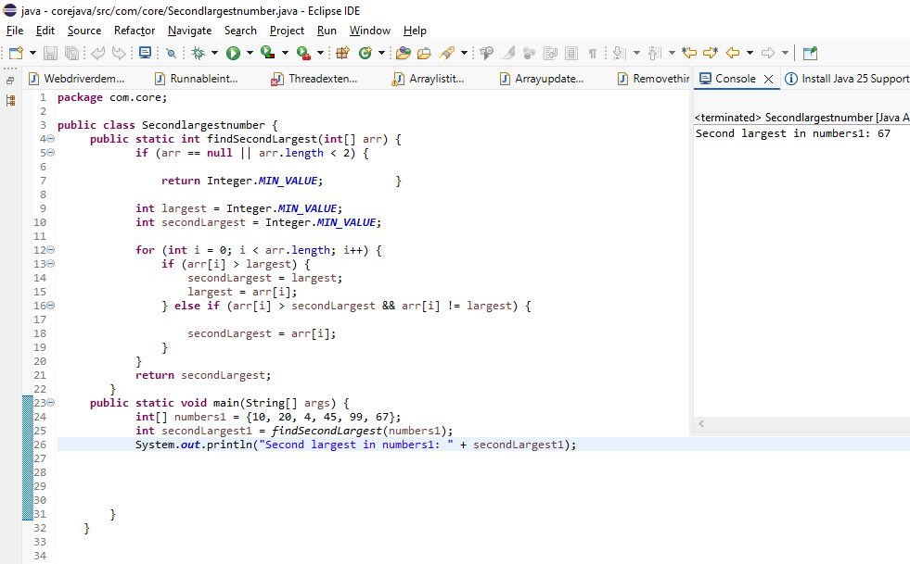
- W.A.J.P. Create an abstract class 'Parent' with a method 'message'. It has two subclasses each having a method with the same name 'message' that prints "This is first subclass" and "This is second subclass" respectively. Call the methods 'message' by creating an object for each subclass.
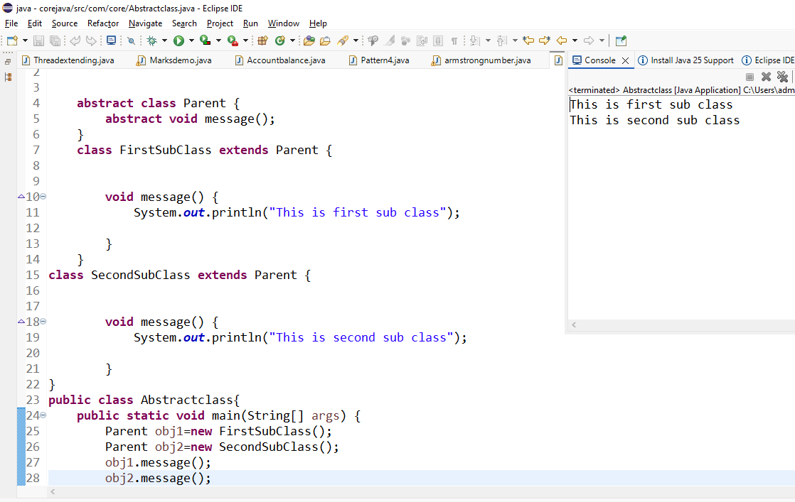
- W.A.J.P. which will ask the user to enter his/her marks (out of 100). Define a method that will display grades according to the marks entered as below:
Marks Grades
91-100 AA
81-90 AB
71-80 BB
61-70 BC
51-60 CD
41-50 DD
<=40 fail
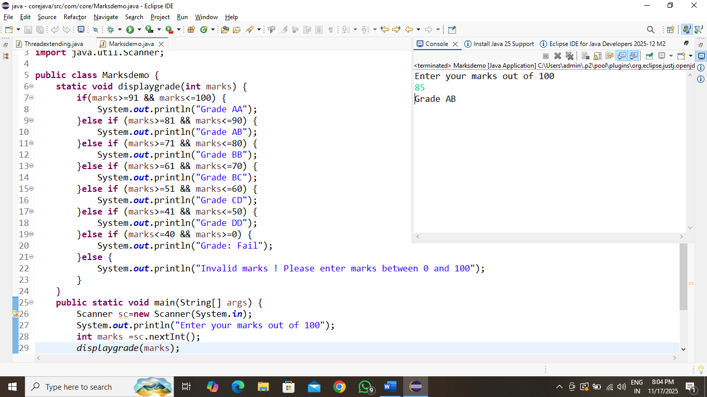
- W.A.J.P. to create a custom exception if Customer withdraw amount which is greater than account balance then program will show custom exception otherwise amount will deduct from account balance. Account balance is:2000 Enter withdraw amount:2500 Sorry, insufficient balance, you need more 500 Rs.To perform this transaction.

